Team Number Independent

## IT1080C Computer Networking Final Project Slugworth Candies Submission Form

**Submission Form**

Using Packet Tracer, create a logical network diagram for Slugworth Candies network using devices and cabling necessary to support this company. Use the Guideline to Final Project to ensure you do not miss any of the requirements.

1. Insert the Packet Tracer diagram in this document. (30 points)

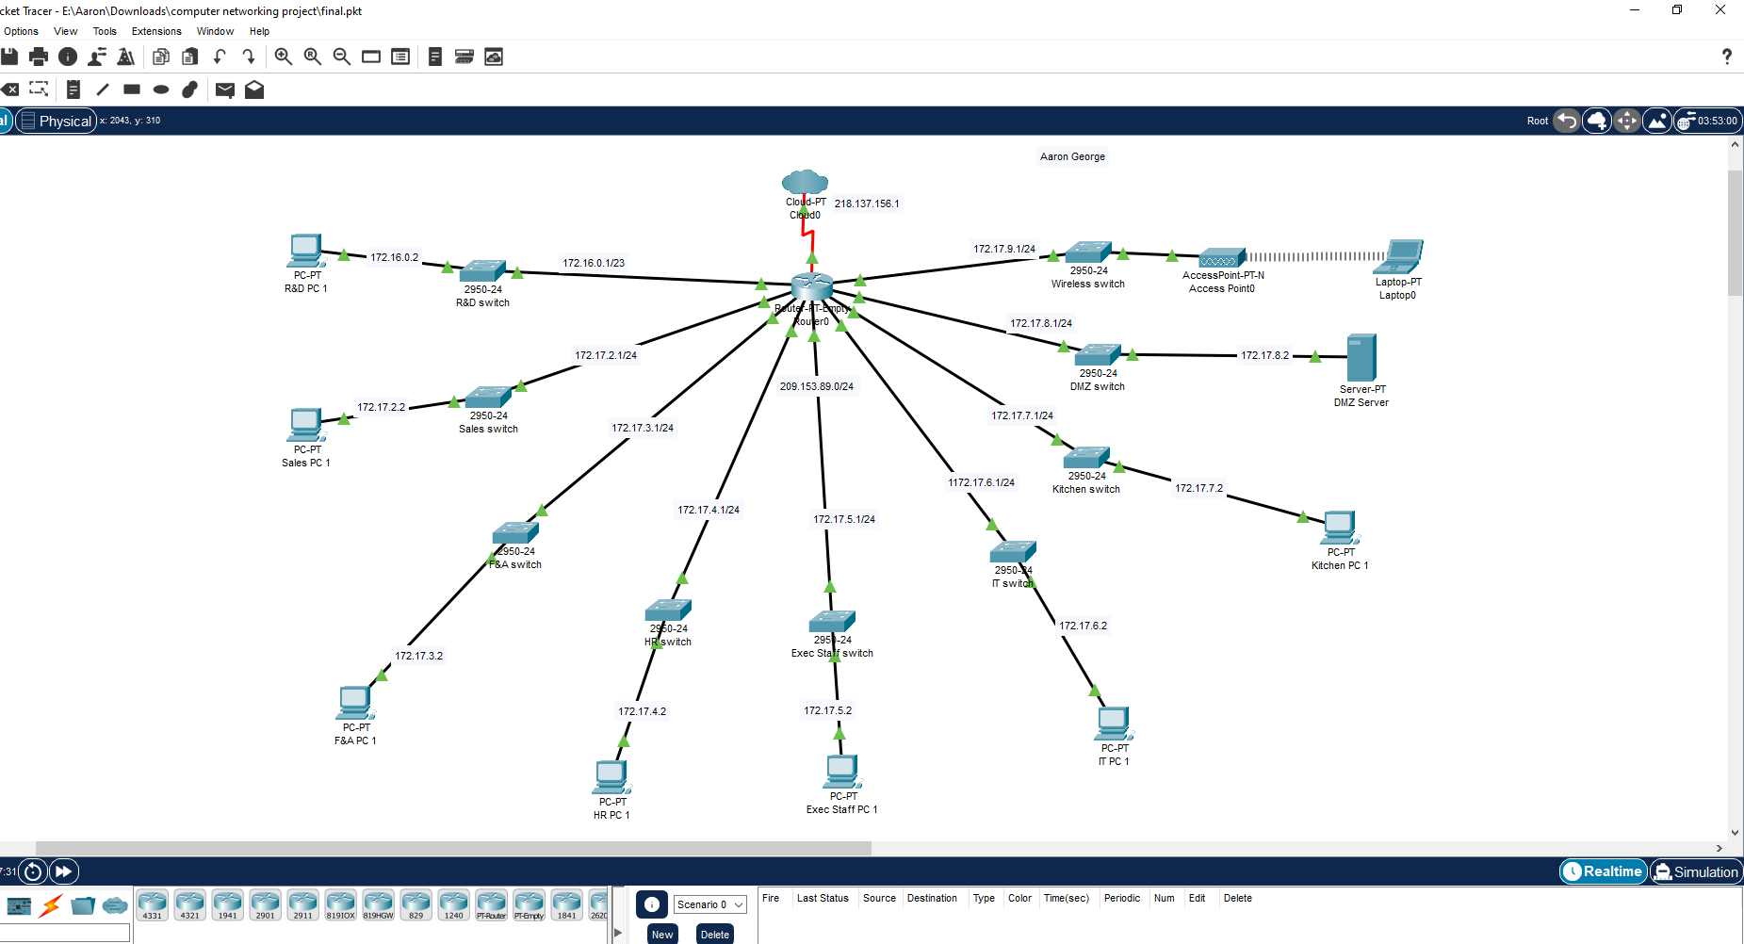

1. List the local area networks, number of hosts to support, the network address with CIDR, and the broadcast address. Use Class B IPv4 private IP addresses. (25 points)

| Local Area Network | Number of Hosts/Devices | Network Address with CIDR | Broadcast Address |
| --- | --- | --- | --- |
| Research & Development | 512 | 172.16.0.0/23 | 172.16.1.255 |
| Finance & Accounting | 256 | 172.17.2.0/24 | 172.17.2.255 |
| Sales | 256 | 172.17.3.0/24 | 172.17.3.255 |
| Human Relations | 256 | 172.17.4.0/24 | 172.17.4.255 |
| Staff | 256 | 172.17.5.0/24 | 172.17.5.255 |
| IT | 256 | 172.17.6.0/24 | 172.17.6.255 |
| Kitchen | 256 | 172.17.7.0/24 | 172.17.7.255 |
| DMZ | 256 | 172.17.8.0/24 | 172.17.8.255 |
| Wireless | 256 | 172.17.9.0/24 | 172.17.9.255 |

1. Which devices are assigned a static private IP address? Explain the decision. (5 points)  
   The devices in the DMZ are assigned a static private Ip address. The dmz is assigned private IP addresses to hide important data.
2. List the contents of the DHCP Server. Do not include statically assigned addresses. (10 points)

| LAN | First IP address in range | Last IP address in range |
| --- | --- | --- |
| Research & Development | 172.16.0.1 | 172.16.1.254 |
| Finance & Accounting | 172.17.2.1 | 172.17.2.255 |
| Sales | 172.17.3.0 | 172.17.3.255 |
| Human Relations | 172.17.4.0 | 172.17.4.255 |
| Staff | 172.17.5.0 | 172.17.5.255 |
| IT | 172.17.6.0 | 172.17.6.255 |
| Kitchen | 172.17.7.0 | 172.17.7.255 |
| Wireless | 172.17.8.0 | 172.17.8.255 |

1. Which device on this network *must* be assigned a public (static) IP address? (5 points)

The router must be assigned a public Ip address.

| Device | IP Address |
| --- | --- |
| Router | 209.153.89.1 |

1. List the range of available public IP addresses in the NAT server. (5 points)

| Server | First IP address in range | Last IP address in range |
| --- | --- | --- |
| NAT Server | 209.153.89.0 | 209.153.89.255 |

1. Complete the table. Enter the name of the protocol data unit and two protocols each layer, and hardware at layers 1 -3. (15 points)

| TCP/IP Layer Name | Protocol Data Unit | Protocols | Hardware |
| --- | --- | --- | --- |
| Application | data | 1. HTTP  2. FTP |  |
| Transport | segments | 1. TCP  2. UDP |  |
| Internet | packet | 1. TCP  2. IP | Modem |
| Network Interface | packets | 1. IPv4  2. IPv6 | NIC |
| Physical | bits | 1. Ethernet  2. Wi-Fi | IEEE 802.3 |

1. Transmission media (5 points).
   1. What type of transmission media is used to connect switches and hosts?   
      An Ethernet cable is used to connect to switches and hosts.
   2. What type of transmission media is used to connect switches to the router?

Twisted wire pair is a physical transmission media used to connect switches to a router.